Lab 01 - Installing VMs

## To work remotely, you will need to install the VMRC client for vSphere web access. These [instructions](https://docs.google.com/document/d/10TmFLHNnx2-ah3uiZhZHUT-OYL7zc-Fec1OYI7nWrMQ/edit?usp=sharing) explain how to install VMRC, as well as how to connect to the ISU VPN. You must use the VPN if you are off campus. You can technically connect to iselab01.ece.iastate.edu without the VPN. But once you try to use VMRC to manage your desktop or server, you MUST use the VPN.

## Getting Support

When you have a question about the lab you need to [contact the TAs via the class’s Slack workspace](https://docs.google.com/document/d/1Hy-saZBC1vOiYDugOnpllAvRUQ7uXa-FgjxCCxbG_Dg/edit?usp=sharing). They are able to see your virtual machines and help you remotely with them. They will also have office hours where you can work with them if you have a problem. If they ask you for your password to your Ubuntu box, please give it to them. **They will not ask you for your Net-ID password.** No one at Iowa State, including ITS, will ever ask you for your Net-ID password.

Additionally, *common Unix commands* and *intros to common Unix text editors* can be found [here](https://docs.google.com/document/d/1cQw34n61z04T3WEv_oWglbYFKP6zt0-JOKHwxiXIgp8/edit?usp=sharing), in addition to links to more detailed articles. We will cover this more in depth in the lab next week.

# Intro

## What is ISELab?

The ISELab is an implementation of the Internet-Scale Event and Attack Generation Environment (ISEAGE) which is an Internet testbed. ISELab allows us to give you a fully-functional public IP address space and air-gapped Internet access, so you can implement your own "corporate" network over the course of the semester.  
  
The class ISELab is part of a medium-sized vCenter cluster managed by the department. To manage and set up your systems in your "corporate" network you will need to remotely connect to the ISELab. Students have a resource pool and folder based upon their login information (Net-ID). The resource pool and folder stores their virtual machines and allocates the usage of CPU and RAM.

You will use the vSphere web application to connect to the ISELab for setup and management. You have instructions above for installing the VMRC client and connecting to the ISU VPN. These are necessary for use in your residence hall or apartment.

## Tasks

Today you will be focused on

1. Logging into vSphere
2. Creating a New Virtual Machine
3. Installing the Operating System
4. Configuring Networking Settings

Please be sure to **read all instructions,** as it is important to understand what is going on as we walk you through the steps. You will be creating several machines throughout the semester and **this lab will come in handy as a reference later**.

## 

# Logging into vSphere

1. Navigate to <https://iselab01.ece.iastate.edu/>. You may be presented with a security warning if you use Firefox - this is okay. Select "Advanced" and click "Add Exception". We will actually discuss why this message was displayed in a later class. For now, we will continue with the exception. You should only need to do this once.

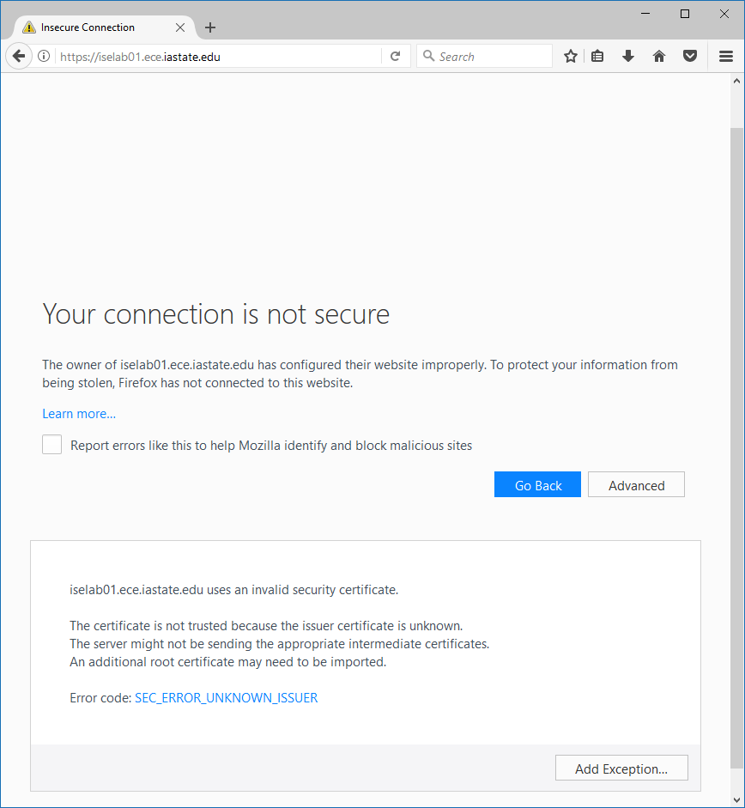

1. Click "Launch vSphere Client (HTML5)".

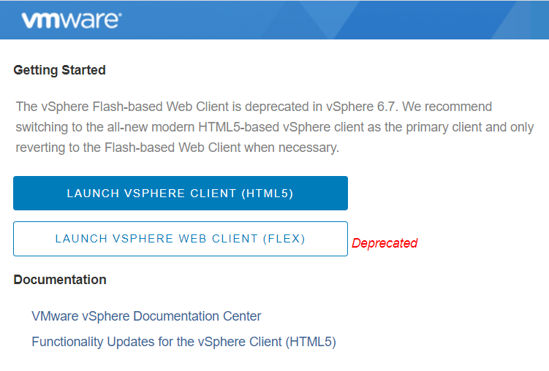

1. You should land on a page like below. Login using your ISU email address (with @iastate.edu) and password (same as CyMail).

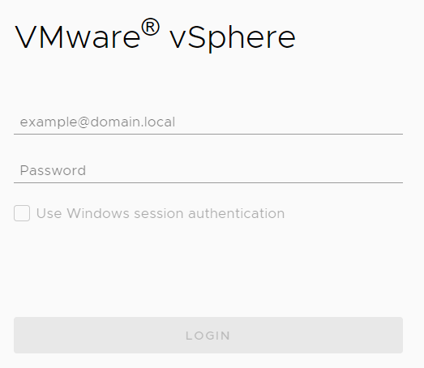

# Creating a New Virtual Machine

1. You will be working with the VMs and Templates, so click on that icon .

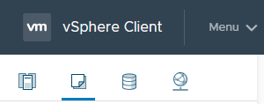

1. Next, expand the directories until you see the folder with your ISU NetID (sstudent is shown in this image).

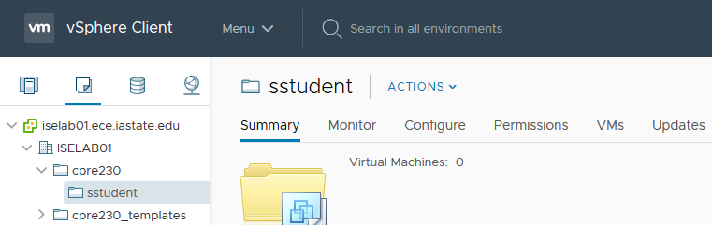

1. Right click on your folder and select New Virtual Machine.

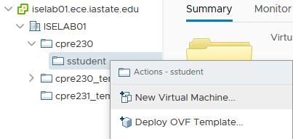

1. Ensure that "Create a new virtual machine" is selected, then click "Next".

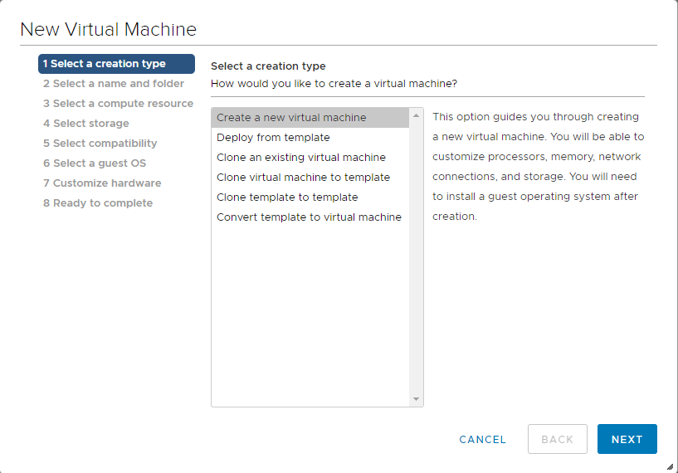

1. **NAMING CONVENTION** - Name your machine such that it contains the class number, your NetID, and some identifying information about its OS and purpose. For example, **cpre230_<your NetID>_UbuntuDesktop** in this case. It will help the TAs find your machine more quickly when they have to troubleshoot. In the inventory location, ensure that you are in your directory**.** Click "Next".

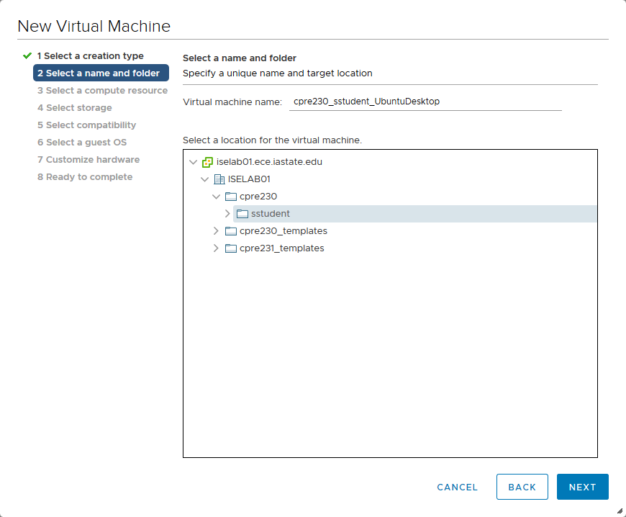

1. Next you will have to locate your resource pool. Your resource pool is tied to the server your IP range is associated with. Open the [student network information spreadsheet](https://docs.google.com/spreadsheets/d/1R5J2njtK2FHUmtCnFyUdIA1zNvSklBBygKaYGKDfSrw/edit?usp=sharing) and search for **your NetID**. Your isehost is listed there. Select the correct isehost and you will see your resource pool, and click "Next".

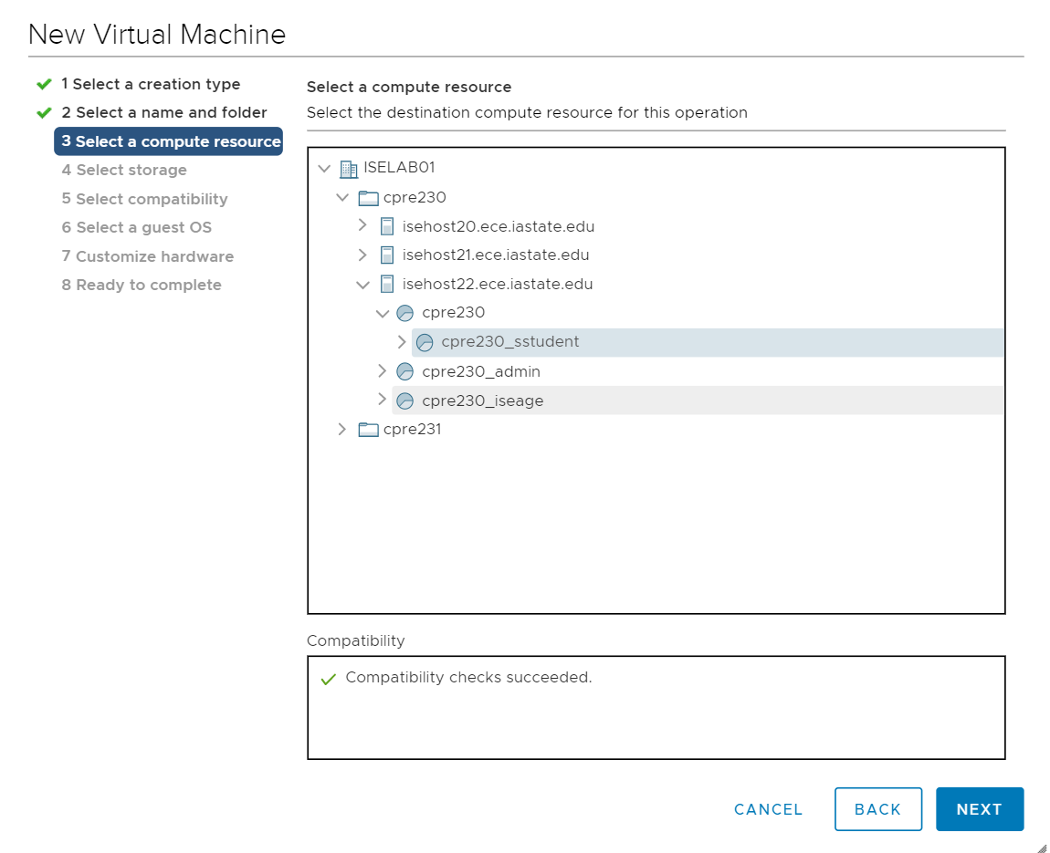

1. Select the **"cpre230"** storage as the destination to store configuration and disk files, then click "Next".

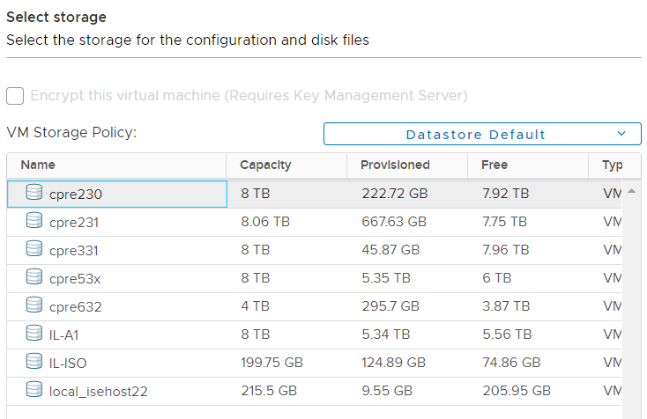

1. Leave the ESXi compatibility to be the latest version (6.7) and click "Next".

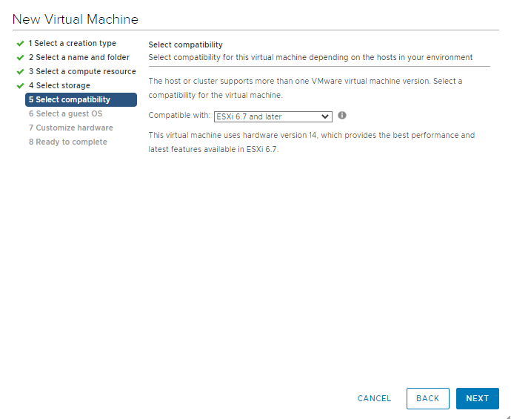

1. Select the OS of the machine you are installing. For this lab, we are installing a Linux Ubuntu 64-bit system. Click "Next".

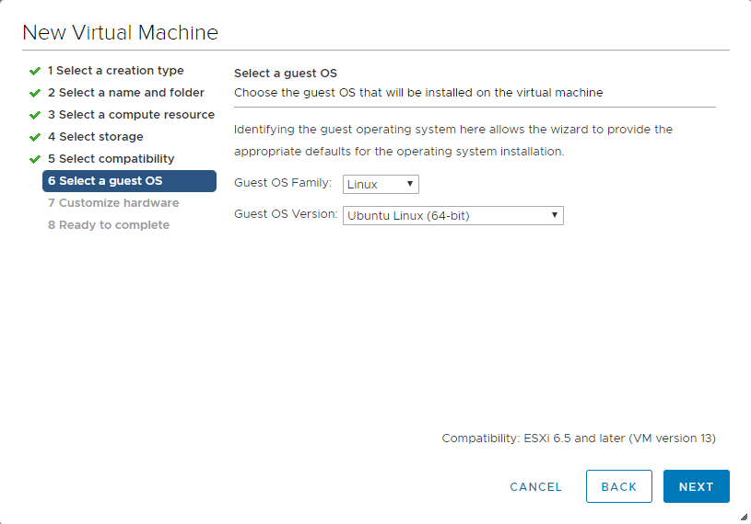

1. Now, you will configure the various hardware aspects of your new system. Keep all defaults, and only change the following items:
   1. CPU: 2  
      Memory: 4 GB  
      Hard disk: (up to) 25 GB
   2. ******* VERY IMPORTANT *********  
      **Ensure that Disk Provisioning under New Hard disk is set to "Thin Provision"**

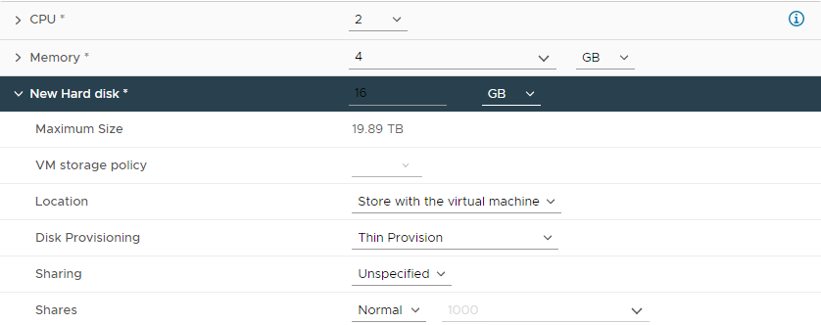

* 1. Network: cpre230_blueX **NOT the network named after your NetID**

(You must **manually** select cpre230_blueX, from the dropdown.)

* + 1. Refer to the [student network information spreadsheet](https://docs.google.com/spreadsheets/d/1R5J2njtK2FHUmtCnFyUdIA1zNvSklBBygKaYGKDfSrw/edit?usp=sharing)



* 1. Switch the video card to "Auto-detect settings". This will allow you to change the resolution of your Ubuntu Desktop machine (only required for Ubuntu Desktop machines).



1. Go to the VM Options tab, expand the Advanced row, scroll down to the Configuration Parameters row, and click EDIT CONFIGURATION.
   1. Click the ADD CONFIGURATION PARAMS button, and add the following name-value pairs:
   2. **Name:** isolation.tools.copy.disable  
       **Value:** FALSE
   3. **Name:** isolation.tools.paste.disable  
       **Value:** FALSE
   4. **Name:** isolation.tools.setGUIOptions.enable  
       **Value:** TRUE
   5. **Name:** disk.EnableUUID  
       **Value:** TRUE  
      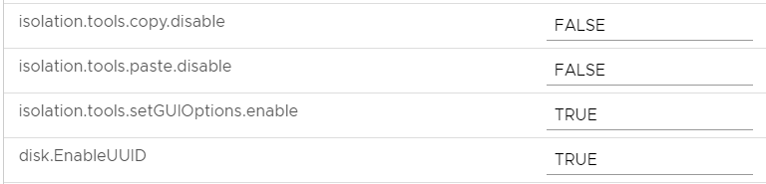  
      The first three parameters enable you to copy-paste to and from the VM, and the fourth prevents persistent disk errors in log files.
   6. Click OK.
2. Return to the Virtual Hardware tab and double check that you’ve specified "Thin Provision" under "New Hard disk", as this can’t be changed later. ***Once you’ve double checked***, click "Next".

***READ THE FOLLOWING***

Many of the settings in this step can be changed later (such as networks and RAM allocation) by right-clicking the VM and choosing "Edit Settings". However, the size and format of a hard disk **cannot be changed after it is created**. It is rarely necessary to assign more than 1 or 2 CPU cores. If you feel like your VM would benefit from more cores, you are required to consult with the TAs before proceeding. We also ask that you keep your **total RAM usage over all machines you get this semester under 13 GB**. It is unlikely you will hit this cap because most servers are not GUI, but, for instance, don’t allocate 4GB of RAM to a firewall. Use good judgment about allocating resources.

1. Finally, click "Finish".

# 

# Installing the Operating System

At this point in the lab, you should now have a virtual machine created within your directory in vSphere. It’s important to note that we’ve just created the "hardware" for our computer - it does not have an operating system at the moment. *We have just customized it to work best with Ubuntu.* If we were to power it on at the moment, we would be greeted with a confused BIOS.

Our next step is to actually install the operating system to our new machine - in this case Ubuntu 22.04 Desktop.

1. We need to "Insert" the installation media into your new machine. To do this, right-click on your new machine, and select "Edit Settings" from the menu.

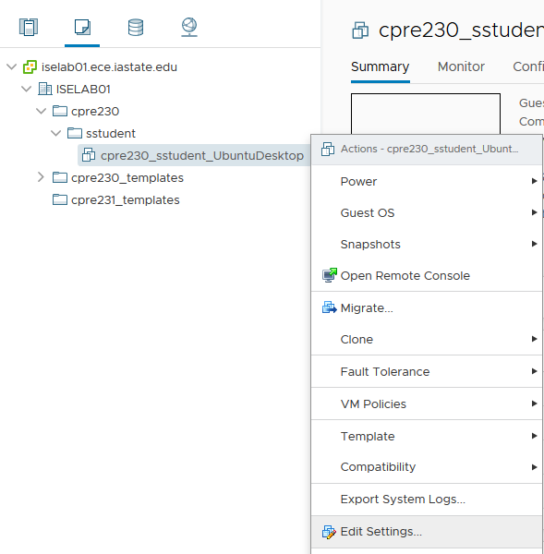

1. From the new window, expand the "CD/DVD" menu. From the drop-down menu, select "Datastore ISO File" from the dropdown menu.

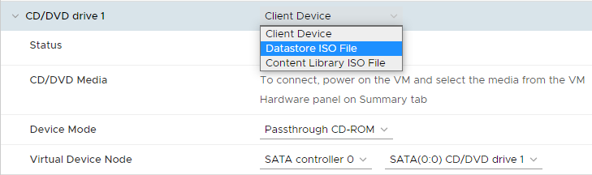

1. From the pop-up menu, select the "IL-ISO" datastore. Here you can see the available installation "discs". Select the "ubuntu-**22**.04-**desktop**-amd64.iso" disk image and click "OK". Make sure you select the version 22 option for a desktop, not a server.

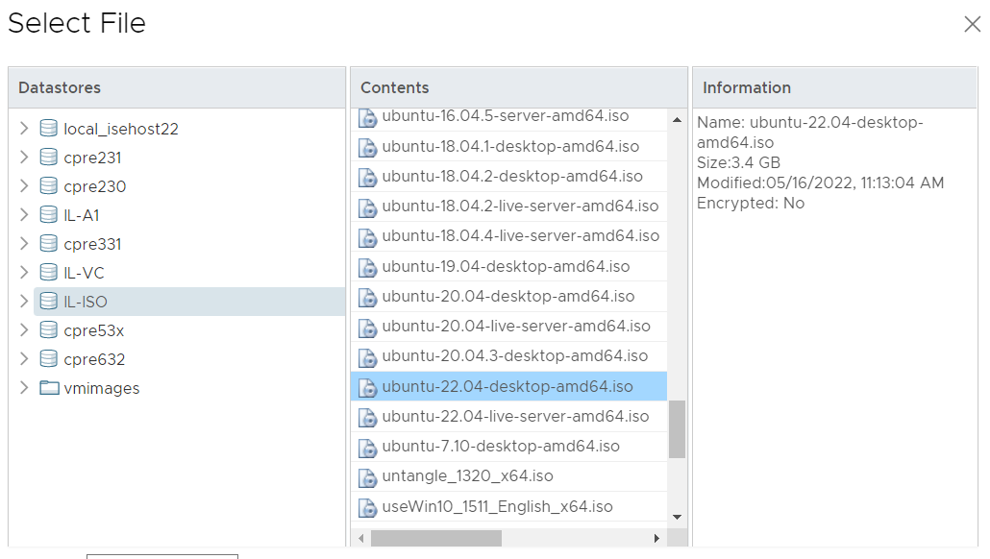

1. Check the "Connect At Power On" checkbox. Click "OK" again to exit from the settings window.



1. Right click your machine’s name in the sidebar, and select Power -> Power On.

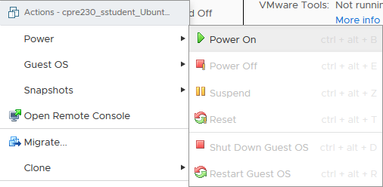

1. To open a console (Be sure you have installed both VMRC and VPN from the [VMRC/VPN support documentation](https://docs.google.com/document/d/10TmFLHNnx2-ah3uiZhZHUT-OYL7zc-Fec1OYI7nWrMQ/edit?usp=sharing) before trying this step), click the desired machine in the sidebar, and click "Launch Remote Console" from below the console preview.

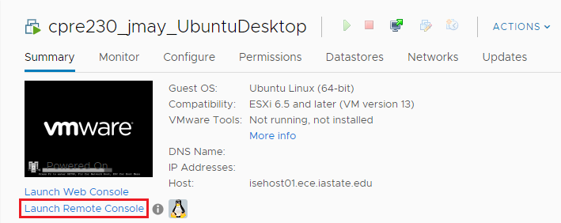

1. You may need to allow pop-ups. If presented with a pop-up window, ensure that "VMware Remote Console" is selected, the "Remember my choice for vmrc links" box is checked, and click "Open link".  
   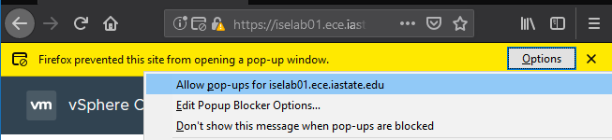

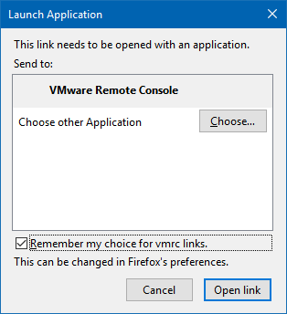

1. If you are presented with the following error/login screen, ensure that you are either on the ISU network or logged in via VPN.

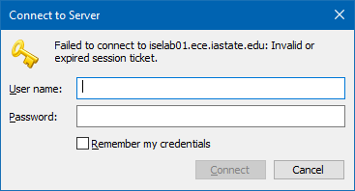

1. You should be presented with a Remote Console for the selected machine.

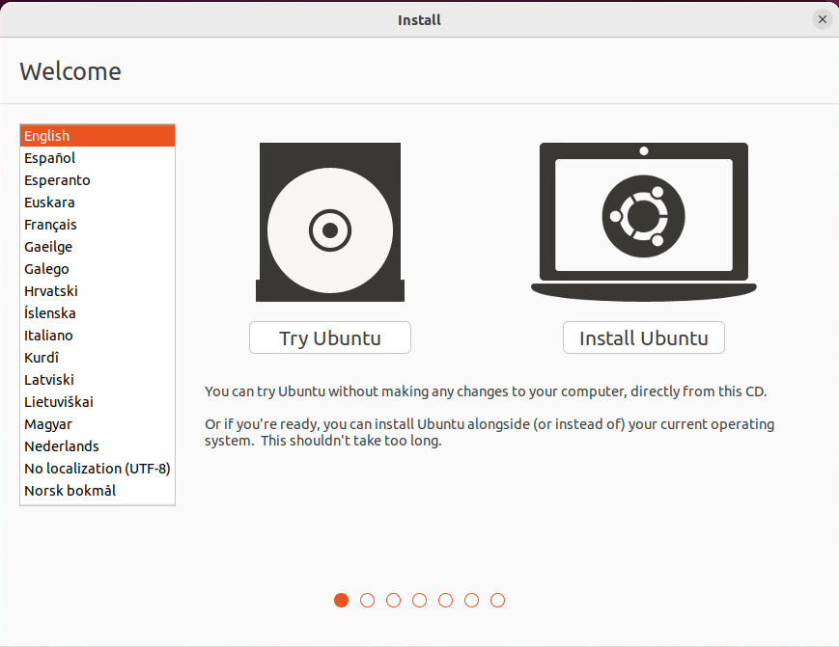

1. After you’ve opened a VMRC to your virtual machine, we can start the installation process. Select the "Install Ubuntu" and follow the on-screen instructions. When prompted, choose a "normal" installation.

1. Select the option to *"Erase disk and Install Ubuntu"* when you reach this screen. *Most* of the default values can be kept.
2. When asked to set up an account:
   1. Enter your first and last name.
   2. Name your computer "desktop".
   3. Set your username as your NetID.
   4. Set your password to “cpre230”.
      1. This is not a secure practice, but it is very convenient for you and the TAs when they need to login to your machines.

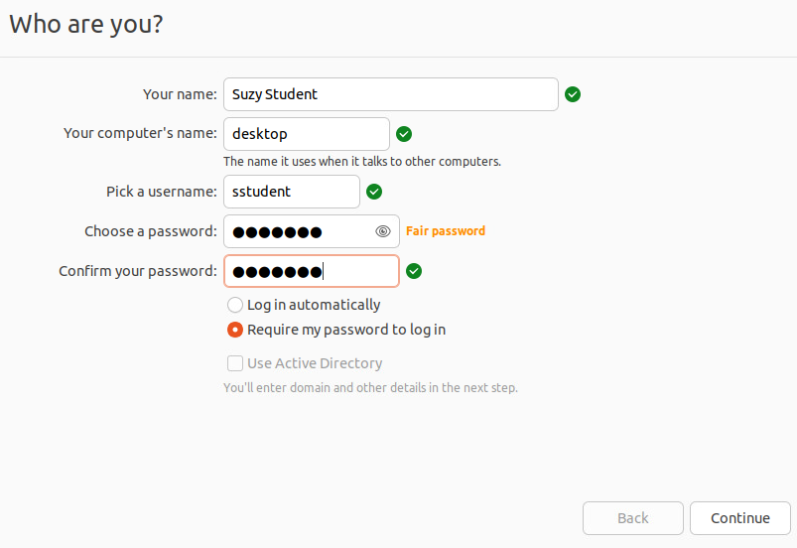

1. Once the installation is complete, you will be prompted to restart the computer. Click restart and return to the settings and disconnect the CD/DVD ISO.

1. To disconnect the CD/DVD ISO, right click your VM and click, “Edit Settings”

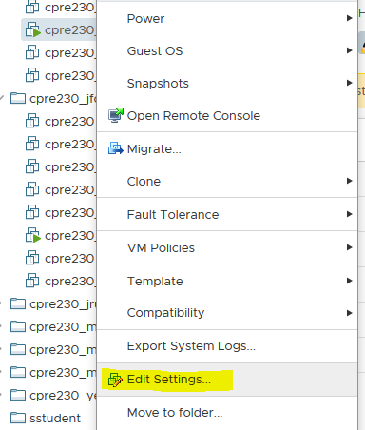

1. Expand the CD/DVD drive. Change “Datastore ISO File” back to “Client Device”. Click “Ok”. You can now either reboot your VM, or push “enter” if the VM prompts to do so.



1. After rebooting you will need to configure your IP to be statically assigned. When you are connected to cpre230_blueX, you will *always have to statically configure your IP*. The instructions below step you through that process.

# Configuring Network Settings

**Networks through ISELab**

Anything connected to the "Blue" networks (cpre230_blueX) must have a static IP assigned and have the default gateway and DNS statically configured. As we will discuss later in class, the IP address helps the network identify your specific machine, while the gateway tells your machine where to send outgoing communication to be "routed" to other machines.

Your IP range and domain are listed in this [document](https://docs.google.com/spreadsheets/d/1R5J2njtK2FHUmtCnFyUdIA1zNvSklBBygKaYGKDfSrw/edit?usp=sharing). You will use the **XXX.XXX.XXX.201** IP address in your range ***for this machine****.* The first three octets in your IP address range should be substituted for XXX.XXX.XXX throughout the semester. Other machines throughout the semester will be assigned different addresses within this same range. As you assign IP addresses, be sure to record which machines they are associated with since they are very important for further configuration and documentation.

Your default route (gateway) is the IP sitting at .254 of your range and must not be assigned as an IP address to any of your machines. For example, XXX.XXX.XXX.254 where XXX.XXX.XXX is the first three octets of your IP range. The netmask is 255.255.255.0 (a /24 subnet). For this first lab, the DNS server is located at 199.100.16.100. In a future lab, you will build your own DNS server. If your network is set up correctly, you should always be able to ping the DNS server and get a response. ***Note*** *that due to the way the ISELab network is structured you will not be able to ping the real world (e.g. google.com)*.

1. On your first login, you will be greeted with "what's new to Ubuntu". You may leave the defaults and click "Next" through all the pages and "Done" at the end.
2. We need to find the name of the network device we are going to configure - this can be accomplished via running the **ip addr** command in a terminal window on your Ubuntu Desktop. Search for Terminal in Activities (once open, you can scroll down, right-click the icon in the dock, and select "Add to Favorites" for easy access), and run the **ip addr** command. Take note of the assigned network device name. You are looking for an ensXXX interface name. In the picture below, you can see that our network interface is **ens160**. Yours may or may not be the same.

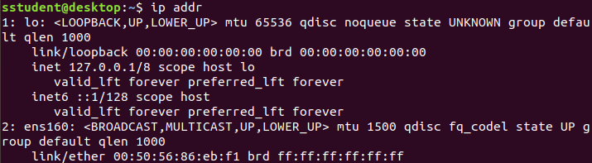

1. The next few commands we will be doing need to be issued at the "super user" level, or from the root account. Run the following command from a terminal to gain a shell with root permissions:

sudo -s

**IMPORTANT:** Your prompt (the bit before the flashing cursor) should now say root@desktop, as in the picture below. Ensure that you see this prompt before running the rest of this lab’s commands. Take note that a utility like sudo ("do as super") is usually used to run selected commands as root instead of running all commands as root from a root session, as logging in as root gives you godlike powers (shoot first, ask later) and can easily lead to painful mistakes and borked systems. Since we need to run many commands as root, it would be tedious to prefix every command with sudo. So we used sudo -s to start an interactive shell as root, making every command we run in this shell run as root. A quick way to see if you are root is to see if you have a ‘#’ sign in your terminal prompt. If you have a ‘$’, you are still a regular user.



1. After establishing the network device name, we need to configure the device. Use your favorite text editor ([vi or nano](https://docs.google.com/document/d/1cQw34n61z04T3WEv_oWglbYFKP6zt0-JOKHwxiXIgp8/edit?usp=sharing)) to create the file **/etc/netplan/01-netcfg.yaml**. If you have no prior knowledge, *nano is recommended*.

vi /etc/netplan/01-netcfg.yaml

**---OR---**

nano /etc/netplan/01-netcfg.yaml

Add the following lines to the file (**the IP addresses below are examples only**):

Important Note: in .yaml files, whitespace matters. **Make sure each indent is two spaces, not tabs.**

network:

version: 2

renderer: networkd

ethernets:

<network device name>:

addresses: [X.X.X.201/24]

routes:

- to: default

via: X.X.X.254

nameservers:

addresses: [199.100.16.100]

Where <network device name> is the name observed from the ip addr command, and **substitute your IP address range for the** X.X.X.254 and X.X.X.201from the networking [document](https://docs.google.com/spreadsheets/d/1R5J2njtK2FHUmtCnFyUdIA1zNvSklBBygKaYGKDfSrw/edit?usp=sharing). You should still use the .201 address under address, and .254 for gateway. Save the file when you have completed typing the commands. The finished file should look similar to the following:

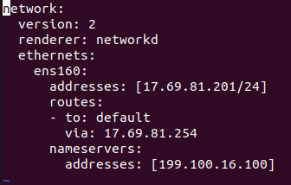

1. The system defaults to using NetworkManager, which we will not use. Remove the NetworkManager configuration by running:  
     
   rm /etc/netplan/01-network-manager-all.yaml
2. Apply the network configuration by running:

netplan apply

1. Do another ip addr command to see if the new IP was taken. Take a screenshot of this, because you will need to include it in your lab report you will eventually upload to Canvas. A quick way to take a screenshot (no matter the operating system) is to make the window active (click on it) and then press Alt + print Screen on your keyboard. If you are using Windows, you can also use the Snipping Tool to take screenshots.
2. Issue the **ping** command against your default gateway. If you do not know how to ping, you can type “man ping” in the terminal to bring up a manual. You can also use the internet to learn what it is and how to use it. You will need to do another screenshot of the result because this too will be included in the pdf file you will upload to Canvas. Type Ctrl+C to stop the ping, otherwise it will just keep running.Take a screenshot of the output of your ping command. (*Note: If you see 100% packet loss, you have a networking error. Generally speaking for all labs, you will not get credit for a screenshot if the output is not successful*)
   1. If you are unsuccessful in pinging your gateway IP address, try rebooting your machine and double check your interfaces file for typos.
3. Once on the network (cpre230_blueX), you will not have access to the internet. Instead, you must use our proxy server, located at 199.100.16.100, port 3128. There are (usually) two steps in the process. The first step is to add environment exports to tell most commands to use the proxy.

(A quick and safe way to edit a file is to type the first few characters of the file path, and push tab once or twice. This can automatically fill out the file or folder you are looking for, often saving you the headache of a typo) Using *vi* or *nano* (again, with sudo or as root), **append the following lines** to the file /etc/environment.

*A useful tip:* Linux uses [tab-completion](https://en.wikipedia.org/wiki/Command-line_completion). This means you can type “/etc/env” and hit tab, which will auto-complete the rest of the filename. Using tab-completion can help prevent typos, make typing commands faster, and offers a quality of life bonus. It would be wise to get into the habit of using tab completion

http_proxy="http://199.100.16.100:3128"

https_proxy="http://199.100.16.100:3128"

ftp_proxy="http://199.100.16.100:3128"

1. For some situations, we do not want to use the proxy. We use the proxy when we want to communicate with websites and computers that are not inside iselab (Google, youtube, etc). We would not need to use the proxy for machines within iselab. This is equivalent to sending mail to your neighbor. After all, you don’t need to use UPS to send mail to your neighbor when they live right across the street. In your favorite editor, **append the following** 2 lines to /etc/profile to the end of the file.

**When editing this file, replace XX.XX.XX with the first 3 octets of *your IP address.\*\**

printf -v no_proxy '%s,' XX.XX.XX.{1..254}

export no_proxy="localhost,.230.com,127.0.0.1,${no_proxy%,}"

This will configure the proxy for just about any command. To allow these changes to take effect, reboot your virtual machine.

1. Now that we have a network connection and our proxy configured to allow access to the outside world, we will update the packages on our machine. This may take some time, so feel free to get a coffee or chat with your neighbor about your favorite security happening in the news.

sudo apt update

sudo apt -y full-upgrade

Note: if you get an error message about “Release is not valid yet”, that means the clock on your VM has the wrong time. You can resolve the issue using [timedatectl](https://www.tecmint.com/set-time-timezone-and-synchronize-time-using-timedatectl-command/).

1. Issue the following command to install the vmware-tools suite, allowing for better interaction between Ubuntu and vSphere.

sudo apt install open-vm-tools

After installing the vmware-tools, you will be able to resize or maximize the VMRC window to get more screen space.

1. Now that the proxy has been set and DNS over HTTPS disabled, you should be able to use Firefox to bring up the ISU homepage. Please take a screenshot of this as well, since it too will need to be turned in as part of the lab submission pdf.

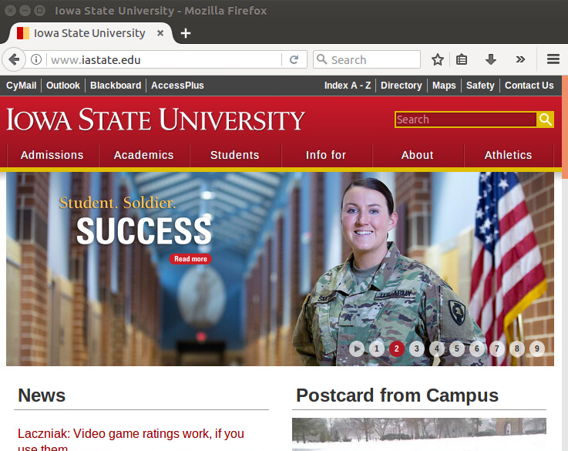

1. You may want to download and install Chrome as a backup web browser. The labs will always reference Firefox. Please don’t choose other browsers and expect the TAs to support them. [THEREFORE THIS STEP IS OPTIONAL]
   1. To install Chrome, go to <https://www.google.com/chrome/downloads/> (on your VM)
   2. Click Download Chrome.
   3. Select the option for Debian/Ubuntu, and click Accept and Install.
   4. In a terminal, go to your Downloads folder. You should see a file named something like google-chrome-stable_current_amd64.deb. Enter the following command, using the filename from your download:  
      sudo dpkg -i google-chrome-stable_current_amd64.deb
   5. Once the installation completes, you will be able to find Chrome in your Activities menu (and add it to your favorites if you so desire).

# Taking a snapshot

1. There will be times when you may want to save your progress on a VM. In order to do this, we will create what is called a “snapshot”. A snapshot is a saved state of a machine that you can revert back to if something were to break. To create a snapshot, right click on your machine you wish to save.
2. Hover over “Snapshots” and click “Take Snapshot…” 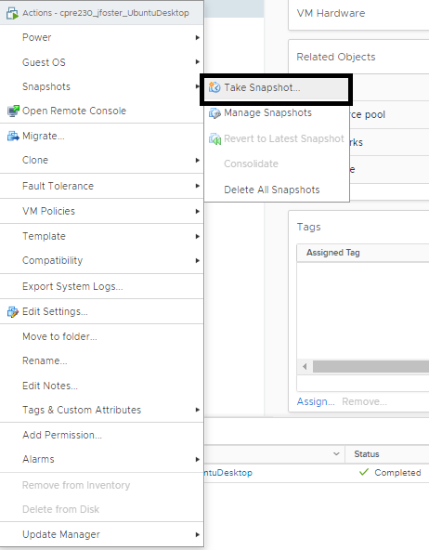

1. Name the snapshot whatever you want, fill out a description, and click “ok”.
   1. To revert to a snapshot, repeat step 1 but instead taking a snapshot, select “Revert to Latest Snapshot”. Note: All progress after the latest snapshot will be lost.
2. Snapshots use storage space on the cpre230 datastore. You do not need to make them after every step in a lab. But you may want to make a snapshot before every major change you make (adding a new service for example). That way it is easy to revert if you have an oops during configuration.

# Turn-in

For your lab report, you will be working off of the “Lab 01 Template” that is provided at the end of this document. If you do not use the Lab 01 Template, you will be docked points. After you have completed your lab report, export it as a PDF file, and upload it to Canvas by 11:59pm the night before your lab next week. (For instance, if you have a 230 Lab on Thursday each week, you need to submit your labs by 11:59 p.m. on Wednesday.)

General Notes for Cpr E 230:

1. Labs are cumulative, they build off of each other.
   1. (Example: If Lab 1 isn’t completed, Lab 3 will not work. If Lab 2 is not completed, Lab 3 will not work, etc.)
2. Late/Wrong lab submissions are not accepted
   1. Don’t let yourself forget to submit a lab! Set alarms a few hours before your lab submission is due to remind you to submit the lab. If you forget, you get a zero for that lab.
   2. After submitting your lab document, download the PDF you uploaded to make sure you submitted the right file. If the right file is not uploaded by the deadline, you’ll get a zero for that lab.

1. Utilize Office Hours
   1. Each TA holds weekly virtual office hours. It is a smart decision to network with your TAs! They have a broad range of experience, and they love helping out. Each TA during their office hours will monitor the Lab channels on Slack for any questions, and they may open a WebEx session if you want to ask questions face to face.

1. Use Slack
   1. Slack is a place where students are encouraged to ask questions, respond to their classmates’ questions, and receive other information. **Before you post a question in Slack, look through the channel and see if your question has already been answered.**

1. Develop Troubleshooting Skills
   1. Throughout the course, you will run into many errors in the class. As you progress in the semester, try to solve the issue on your own first. A good rule of thumb is to ask for help after you have tried for about five minutes to solve the issue on your own. When you ask for help, a TA will usually ask you, “What do you think the problem is, and what have you tried so far?” Be prepared to answer those questions!

# Lab 01 Template

1. **Successful output of ip addr to show your statically set IP information is correct**

(15 Points)

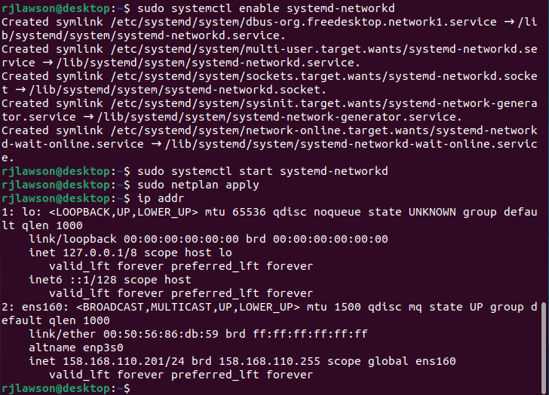

1. **Successful output of ping to your default gateway**

(15 Points)

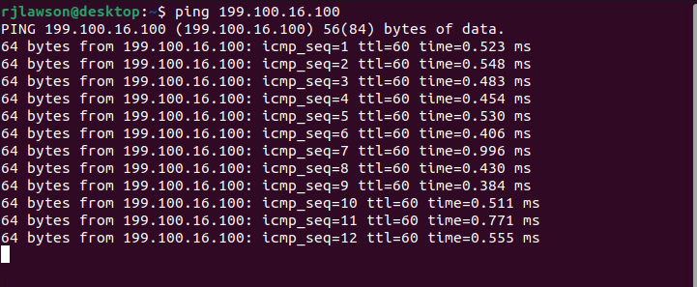

1. **Screenshot of Iowa State’s homepage successfully loading in firefox**

(10 Points)

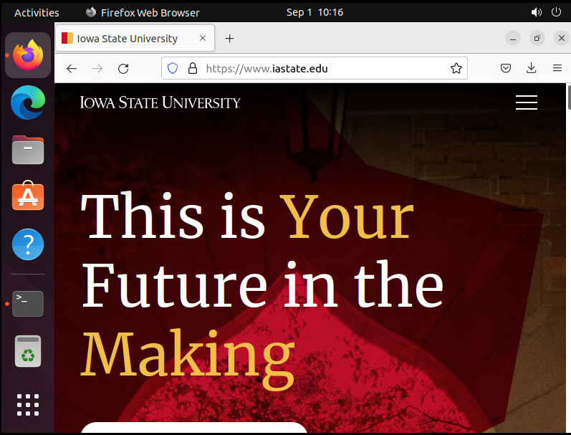

| **File** | **Why is editing this file necessary when setting up my network settings?** |
| --- | --- |
| /etc/netplan/01-netcfg.yaml  (20 Points) | To configure the ip address to the server and to link whatever your ethernet device to these addresses |
| /etc/environment  (20 Points) | To configure proxies to be able to connect in a specified manner |
| /etc/profile  (20 Points) | Configures the system to use the network without a proxy if it can’t find the proxy |